FINAL REPORT
Experiment 2: Designing and Implementing ETL Processes using Microsoft Power BI

Objective
The objective of this experiment was to implement an ETL process using Microsoft Power BI and prepare the Global Superstore dataset for business analysis and reporting.

Work Completed
In this experiment, we worked with the Global Superstore dataset, which contains the Orders, Returns, and People tables. The data was imported into Power BI and prepared using Power Query Editor.
The Orders data was cleaned by removing duplicate and blank records, checking data types, and standardizing important fields. Year and Month were extracted from the Order Date, and a Profit Margin field was created. The Returns data was checked for duplicate Order IDs, missing values, and consistency of the Returned field. The People data was also checked to ensure that regional information was consistent and unnecessary fields were removed.
The Orders and Returns data were integrated using Order ID, while relationships were created between the relevant tables using Order ID and Region. This allowed information from different tables to be connected and used together for analysis.
After the transformation and loading process, DAX measures were created for Total Sales, Total Profit, Profit Margin, and Total Orders. These measures were then used to prepare the final Power BI report and analyze the business data.

Final Outcome
The ETL process was successfully completed. The raw Global Superstore data was converted into a cleaner and more organized dataset that could be used for reporting and analysis. The final Power BI model contained connected tables and useful business measures, making it easier to understand sales, profit, orders, and returns.
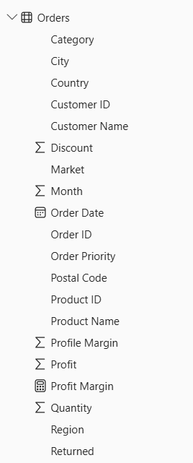

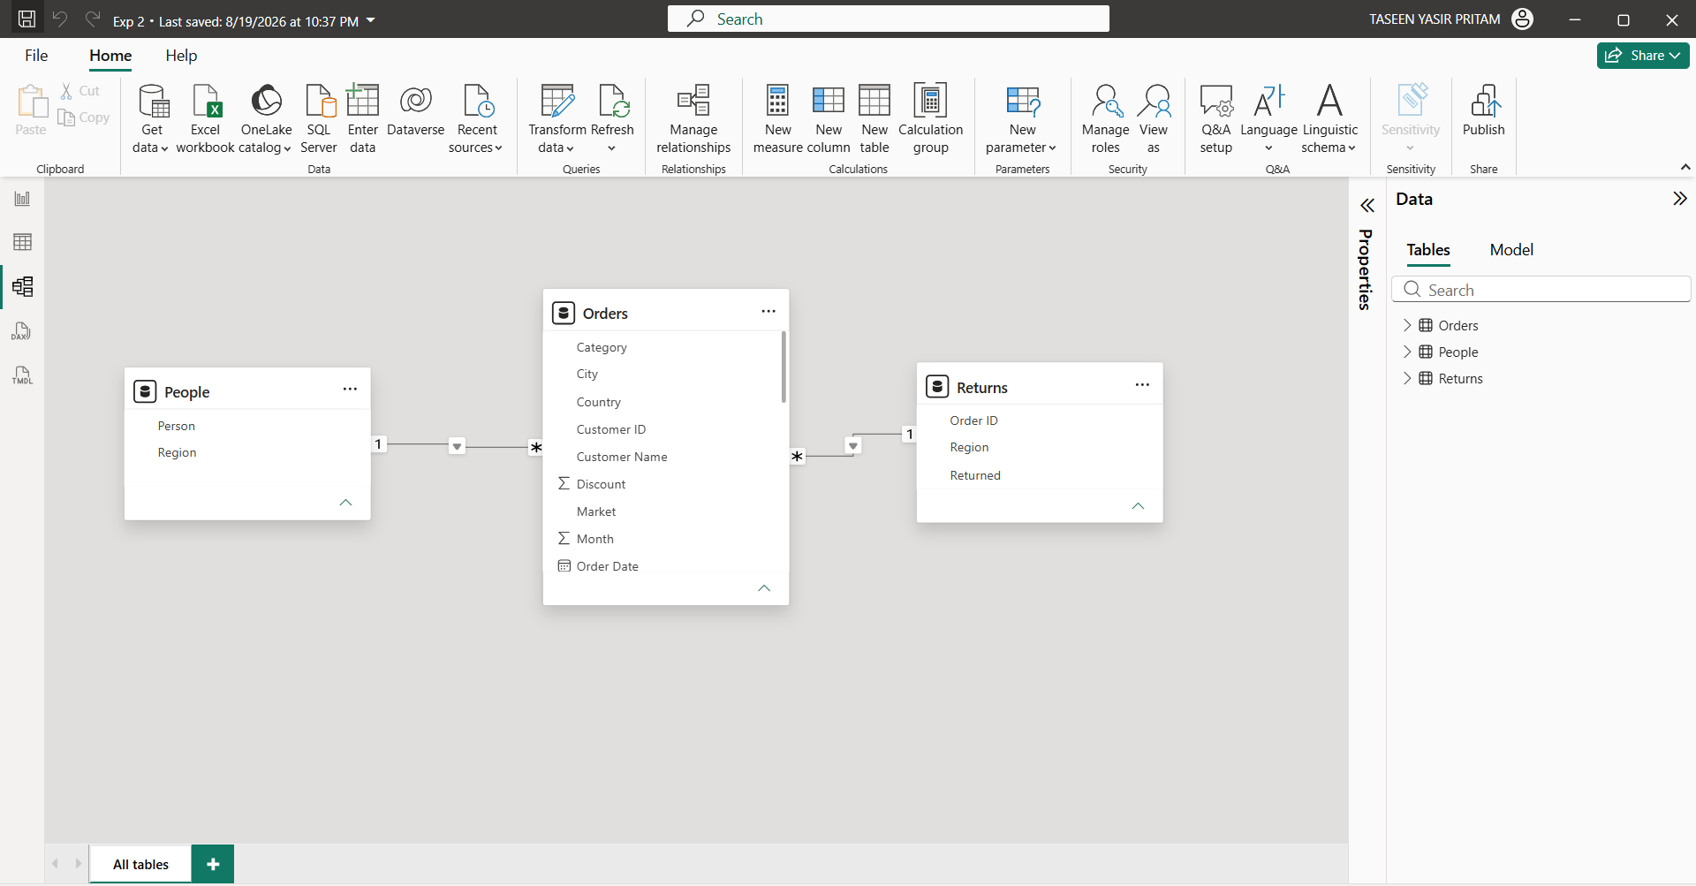

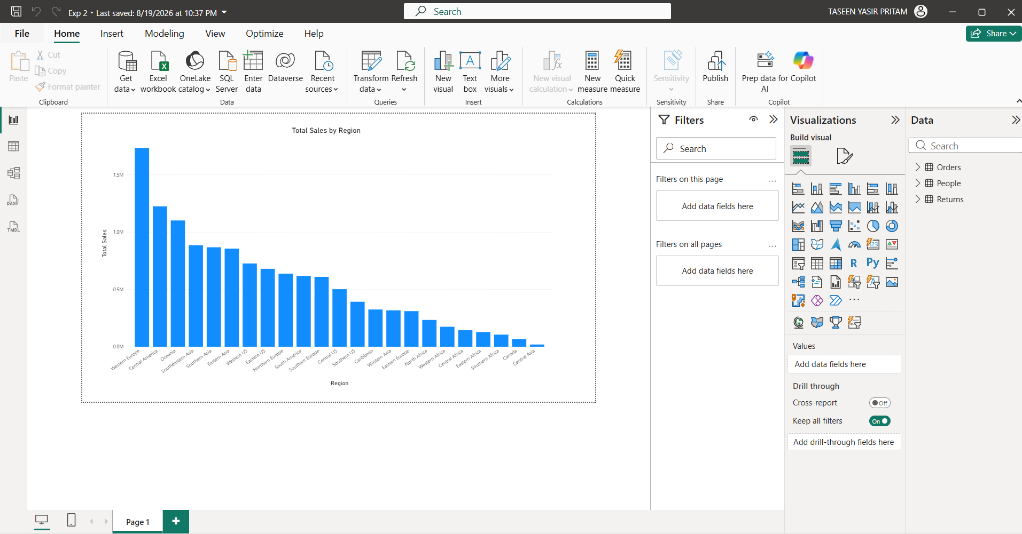
Conclusion
This experiment gave us practical experience with the complete ETL process in Power BI. We learned how to extract data from a real-world dataset, clean and transform it, combine related information, create relationships, and prepare analytical measures. The final data model was successfully prepared for business reporting and decision-making.

